Positive Behavior Management:

Using effective practices in classroom management.

Information Compiled by Aurora Baxter, School Psychologist

Battle Ground School District, May 2005

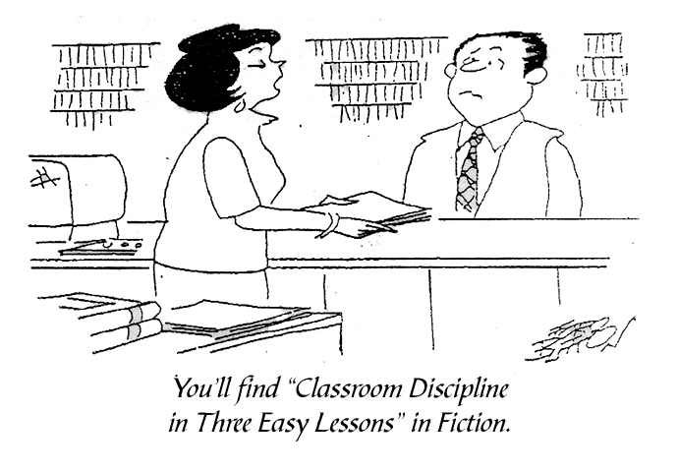

Basic Principals of Positive Behavior Supports

- Teach and practice expected behavior
- Maximize attention for positive behavior & minimize for negative
- Find replacement for negative behavior

Positive Behavior Management:

Using effective practices in classroom management.

Outline

- Establish Expectations
- Identify Your Expectations
- Teach and Practice Procedures
- Use Visual Supports to Clarify Expectations

- Reinforce Expected Behavior
- Establish Rapport
- Use Positive Reinforcement to Shape Behavior
- Modulate Your Response According to Students’ Behavior

- Give Directions
- Get Attention
- State Direction
- Monitor
- Provide Feedback
- Things to Avoid

- Respond Appropriately
- Remain Calm
- Plan Ahead
- Know Your Limits
- Maintain Consistency with Consequences
- Use Planned Ignoring for Attention-Seeking Misbehaviors
- Diffusing Anger and Aggression (DVD)

- Encourage Problem Solving
- Use STAR Model to Encourage Thinking Before Acting
- Teach Sensory Strategies to Help Manage Stress
- Teach Students to Think Differently

- Individualize Behavior Plans
- Understanding Functional Behavior Assessments
- Creating BIPs
- Using Behavior Contracts
- Using Visual Supports to Support Individual Needs

- Be Patient
- Remember…

Appendix
      - Effective Behavior Management Rating
      - Classroom Observation Form
      - Sample Procedures
      - References & Resources

Establish Expectations

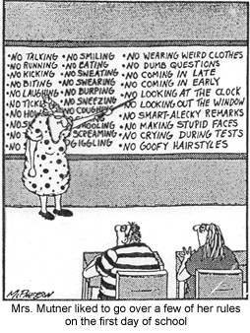

Identify your expectations:

Create a short list of rules and procedures.

Make sure that they:

are simple.

use few words.

are positively stated.
- Display rules publicly at students’ eye level
- Teach and review rules often
- Establish rules immediately – on the first day of school!
(Sprague, et. al. 1999)

Things to keep in mind when making and maintaining rules
- Regularly review and edit rules; don’t wait for a crisis.
- If a rule doesn’t address a problem, discard it.
- Monitor and reinforce when a rule is followed.
- Apply rules consistently to each and every student.

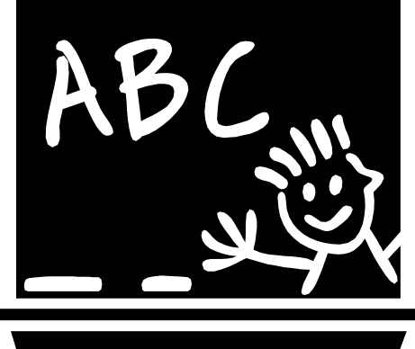

Teach social behavior like academic skills

Teach through multiple examples.

Teach where the problems are occurring.

Give frequent practice opportunities.

Provide useful corrections.

Provide positive feedback.

Monitor for success.
(Sprague, et. al. 1999)

Expectations 1
School Rule/Expectation Lesson Plan

The Topic/Rule: _____________________________________________________________________

What do we expect students to do?
1.
2.
3.

Why is the rule/expectation important?
List examples and non examples of the expected behaviors (two to three each):

- A positive example:

- A non-example:

- A positive example:

Provide opportunities to practice and build fluency:

1.
2.
3.
4.

(Sprague, et. al. 1999)

Expectations 2

Teaching Procedures

A procedure is a sequence of behaviors that are performed in more or less the same manner after time.  Procedures increase…  - student independence.  - classroom harmony.  - classroom efficiency. | 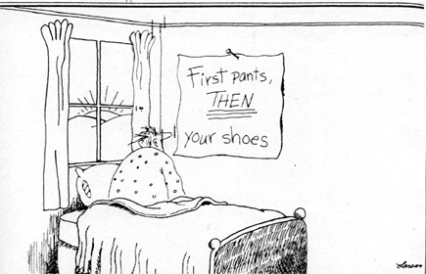
Preparing to teach procedures:
- Identify what you want the group to look like and sound like.
- Develop a rule statement using simple phrases that are few in number and positively stated.
- Develop a set of examples and non-examples to teach concepts.
- Develop role-playing scenarios to practice procedures.

Teach procedures directly

Verbal Repertoire:

Model – recite the steps of the procedure.

Lead – have students practice reciting the steps with you.

Test – have students recite independently.

Retest – have students recite steps individually.

Observer Repertoire:

Demonstrate correct and incorrect examples.

Always start and end with a correct response.

Ensure that incorrect examples vary by only one feature.

Performer Repertoire

Have students practice correct procedures (do not have them practice incorrectly!).

Discuss why procedures are important
- Pre-Correct students when they are expected to use the procedure in real life situations

Build greater independence
- Post procedures prominently
- Use check lists for complicated procedures
- Test students on procedures
- Use unexpected pay-offs when procedure is witnessed
- Offer privileges contingent on using procedures

TIEE 2001
Expectations 3

Using Visual Supports to Clarify Expectations
(excerpts from http://www.usevisualstrategies.com/information.html)
Lots of people benefit from using visual strategies. Do you use a day planner or a calendar or write notes to yourself to help you remember? Then you use visual strategies. All students can benefit from having visual supports to help them remember and understand. But using visual supports can be particularly helpful for students with special learning difficulties. Visual strategies are exceptionally helpful for students with communication or behavior or learning challenges or other special needs
Why are visual supports helpful?
Auditory information is fleeting. It is there and then it is gone. It is transient. That means it comes and then it disappears.
Social interaction requires lots of shifting. . . back and forth. . .from person to person. Effective communication requires the ability to rapidly establish attention and shift attention. We take in information and process it. Then we formulate responses appropriate for the situation. These steps need to happen quickly because social life moves and changes continually.
Our targeted students may experience difficulty accomplishing these skills at the speed necessary to participate effectively in communication interactions. They can have difficulty rapidly establishing or shifting attention. Auditory information may disappear before students have a chance to pay attention enough to take in what is being said. They may miss a lot of information. Students may be accurately interpreting only fragments of communication messages.
Using visual strategies helps. Visual information stays there long enough for the student to see it, take in the information and respond to it. It is non-transient. It doesn't fly away. Students can go back over and over if they need, to understand and remember.
How to you use visual supports:
There are lots of options. Schedules and calendars are the most common visual tools used to give students information. Step-by-step directions, choice boards, and classroom rules provide structure in classrooms. They help students by creating an environment that is more predictable and understandable.
How to Create a Daily Schedule:
- Divide the day into segments
- Give each segment a name
- Select a representation system
a. Consider photographs, line drawings or written words
- Select a format
a. Is it for a whole group or for an individual?
b. Where will you keep it?
i. On a wall
ii. On a desk
iii. Teacher carries it in a book
iv. Student carries it in his pocket
- Decide when and how the student will use it throughout the day.
- Teach the student how to use the schedule.
- Use the schedule to give the student information about what is happening, what is changing, and anything else he needs to know.
Expectations 4
Reinforce Expected Behavior

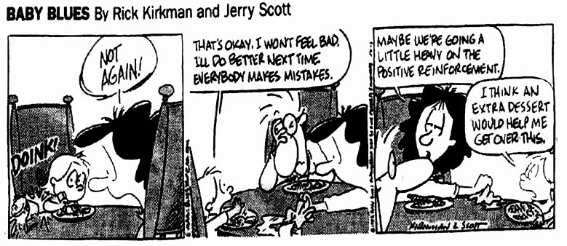

Establish rapport

It is important to establish rapport with students because it increases the likelihood of them following directions.

Ways to establish rapport:

Greet students.

Interact with students.

Pair yourself with reinforcing items.

Catch them when they are doing the right thing.

Use positive reinforcement to shape behavior

Research has shown that positive reinforcement is more effective in shaping behavior than punishment.

Reinforcement defined: Something that increases a desired behavior. Payoffs are not considered reinforcers if they do not increase desired behavior. The value of reinforcers is always changing, so they need to change often.

Rules of reinforcement: Behaviors that are reinforced will be repeated. Behaviors that are maintained are reinforced.

Find out what motivates specific students: To be considered a reinforcer, a student pay-off must be motivating to the student.

Guidelines for Shaping Behavior:

- Provide opportunities for success.
- Start praising behavior that approaches goal (i.e. if goal is to sit still in seat, start with praising just for being in seat).
- Use four positive statements for every negative or corrective statement.

Reinforce 1
Types of possible reinforcers:

Adult approval | Peer approval | Competitive approval | Preferred activity | Tangible reward
- Teacher writes “100” or “A” on paper.  - Teacher writes positive comments on paper.  - Teacher gives verbal praise. | - Classmates ask to work with them.  - Friend asks to sit with student.  - Classmates ask to be class leader. | - Answer a question correctly in front of class.  - Have paper shown to class.  - Have paper on bulletin board | - Free time  - Time outside  - Choice in work activity  - Computer time | - Food  - Toys  - Stickers  - Books

Use specific praise as positive reinforcement

Effective praise is:  Specific  Contingent  Immediate  Sincere  Age appropriate | 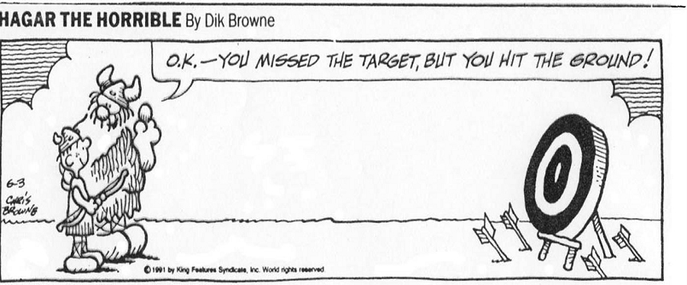

To be specific with your praise, make sure that you tell them what they are doing well. For example, instead of saying “Good job!”, you could say, “Nice job putting your materials away.” Find some statements that work for you. If praise statements feel unnatural at the beginning, try simply acknowledging when students follow directions, e.g. “You are following directions by putting the materials away.”

101 Ways to Praise Kids

That’s incredible!* How extraordinary!* Far out!* Outstanding performance* I can’t get over it!* Great!* Amazing effort!* Unbelievable work* Wonderful!* Marvelous* Phenomenal!* You’ve got it* Superb!* Cool!* Excellent!* You’re special* Your work is out of sight* Your project is first-rate!* You’ve outdone yourself!* Way to go!* Thumbs up* You’re a good friend* You came through!* Terrific* You tried hard* Your help counts!* You made it happen!* It couldn’t be better!* Fantastic work!* You’re a real trooper* Fabulous!* Bravo!* Exceptional!* You-re Unique* Awesome!* Breathtaking!* The time you put in really shows!* You’re a great example for others!* Keep up the good work* I knew you had it in you!* Dynamite* It’s everything I hoped for!* You should be proud of yourself!* What an imagination!* You made the difference!* Well done* You’re sensational* Very good!* A+ Work* Super job* Good for you!* Take a Bow* You figured it out! *Great answer* You’re dong a lot better* Thanks for being honest* How artistic* Hooray for you* You’re a Joy* How thoughtful of you* You’re amazing!* You’re getting there* What a great idea* You deserve a hug* Thanks for trying* You’re getting better* You are a big help* You’re tops* You’ve made progress* You’re neat* You’ve got what it takes* You’re #1* You’re a shining star* You can be trusted* WOW!* Remarkable!* Beautiful* I’m proud of you* Very Impressive* You’re sharp* You’re a winner! Hot dog!* Spectacular work* You’re so kind* What a great listener* Thanks for helping* Great discovery* You’ve earned my respect* Thanks for caring* You’re A-Okay* You’re a great kid* How original* You’re a champ* You’re a pleasure to know* Very brave* What a genius!* You’re very talented* You’re the greatest* You’re Super!* You’re on target!

Reinforce 2
Modulation & Differential Reinforcement

Rule of extinction: Any behaviors for which reinforcement is not available, will diminish and/or extinguish.

Differential reinforcement defined: The systematic use of reinforcers of varying strength in order to teach a target behavior, or to increase the frequency of an appropriate behavior.
For Example: In order to get Shamu to learn to jump, trainers first put a rope on the bottom of the pool, and reward him for swimming over it. Then they raise the rope gradually, and continue to reward him as he gets closer to his goal. Eventually, the rope is raised above the water, and Shamu has learned to jump over it. (Glasser, 2006) | 
Modulation defined: An effective strategy for on-going behavior management which involves varying attributes of teacher behavior (e.g., voice, face, posture, etc.) contingent upon student responses in order to more effectively communicate the potential availability of reinforcement. Modulation is a differential reinforcement strategy.

Elements for Modulation (see next page for continuum):

- Posture
- Face
- Eyes
- Hands
- Words
- Voice Quality
- Reinforcer Access

Critical elements of teacher behavior occur on a continuum:

Student | Off Task…………………………………………………...……………………………On Task
Teacher | Flat/Neutral……………………………………………………….……….….Exuberant/Ecstatic

How does it work? Pairing more access to reinforcing consequences with more interesting and animated affect.

Goal of Modulation: Students learn to predict the availability of reinforcement based on the teacher’s behavior. The teacher is the barometer!

Hint: To increase the effectiveness of your modulated response, be sure reinforcing consequences become more and more available as your behavior modulates up the continuum.

Don’t Get Caught:
- Increasing animation to cajole students back on task.
- Offering/reminding students of potential reinforcers when off task.
- Giving reinforcing items or privileges away FREE

(Taylor, 2001)
Why is modulation important?

Think of adults as the ultimate children’s toy. We are most interesting when we are vibrant and animated. The goal is to save our animation for when students are on task, so that they are not acting out in order to get a “more interesting” reaction.

Reinforce 3
Modulation Continuum

 | Student Behavior
Element | Off task-----------------------------------------On Task
Posture  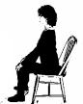 | Stiff, very straight   | Relaxed   |  | Leaning forward  
Face  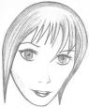 | Taut   | Calm   |  | Smiling/animated  
Eyes  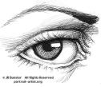 | Gaze averted   | Eye-contact   |  | Sustained eye-contact  
Hands  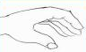 | Still  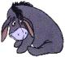 | Relaxed, some movement   |  | Positive gestures & contact  
Words  --- ----- --. | Limited only to Commands/Questions  You need to … | Commands/Questions with affirmations of response  It’s time to….  … Well done! |  | Praise and positive comments  Fabulous!
Voice Quality | Firm/slow  No-nonsense  Exaggerate command | Neutral | Positive | Exuberant/  Interesting  Exaggerate praise
Reinforcer Access | Pushed aside/  Out of view | Brought into view/  Move closer to |  | Delivered

(Taylor, 2001)

Reinforce 4

Give directions

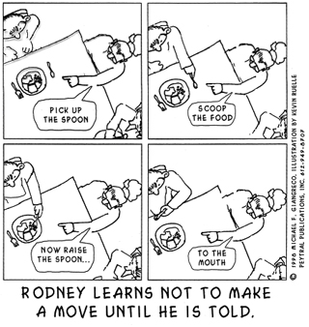

Giving Effective Directions

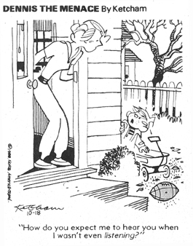 | Get attention before giving direction:  Develop an attention signal for the class  Direct attention of the whole class.  Observe the group.  - Check for individual understanding  Provide attention to those doing the right thing.

State direction:
Use Alpha commands to reduce non-compliance. Avoid Beta commands

Alpha Commands  - Minimal number of words  - Clear, concrete and specific  - Use a matter of fact tone.  - Present multi-step tasks one at a time.  - Reasonable amount of time for behavior to occur | Beta Commands  - Wordy  - Vague  - Often convey feelings of frustration or anger  - May contain many sets of directions
(Sprague et. al. 2001)

Other tips for effective directions:
- State directions positively (i.e. “you need to stay in your seat” instead of “don’t walk around the room”)
- Clarify directions if needed, but do not rationalize or explain why student should comply.
- For “hard” directions, practice following direction before holding students accountable for following through with them.

Directions 1

Monitor:

Use active supervision to monitor whole class behavior.

Move Around
- Be up on your feet
- Supervise entire area where students are
- Intermingle with the students
- If more than one adult in room, space yourself out

Look Around
- Scan the entire area
- Provide eye contact that scans the entire group (i.e., avoid sustained eye contact)

Interact
- Anticipate and intervene
- Observe students who are following directions
- Direct praise statements
- Engage the students in the activity

Provide Feedback:
- Provide attention to students doing the right thing
- Proceed with instruction/activity

Avoid:

Arguing

Explaining

Negotiating

Wavering
- Using “please” or “thank you” if “No” is not an acceptable answer
- Repeating directions over and over
- Giving a directive that you cannot follow through on

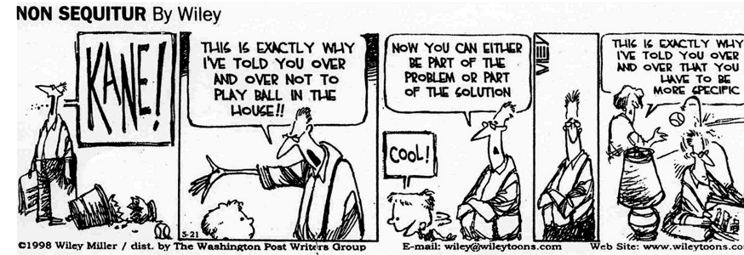

Directions 2

Respond Appropriately

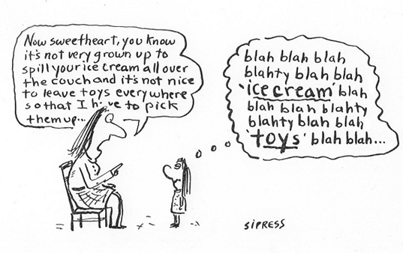

Responding to Negative Behavior

Remain calm

Use a flat tone of voice

Do not take personally

Have an alternative option if you cannot remain neutral.

Plan Ahead: Plan a Specific Request Sequence ahead of time to deal with students who might not comply.

Example Specific Request Sequence
 |  | Specific Request | ⬅ | ⬅
 |  | ⬇ |  |  | 
Compliance | ⬅ | Walk Away and Wait 5-10 Seconds | ➔ | Non-Compliance
⬇ |  |  |  | ⬇ | ⬆
Reinforce! |  |  |  | “You need to _________”  Request in a calm voice
 |  |  |  | ⬇ | ⬆
 |  | Compliance | ⬅ | Walk Away and Wait 5-10 Seconds
 |  | ⬇ |  | ⬇ | ⬆
 |  | Reinforce |  | Non-Compliance
 |  |  |  | ⬇ | ⬆
 |  |  |  | Pre-Planned Consequence | 

(Sprague et. al. 2001)

Know your limits
Answer the following questions about yourself
- If I failed to regain self-control and over-reacted, what would I be doing?
- If I failed to regain self-control and under-reacted, what would I be doing?
- What habits do I display under challenging situations that might make the situation worse?

Create a “concrete plan” for keeping your behavior within professionally acceptable limits. Think of ways to change your:
- Breathing  - Vision | - Speech  - Thinking | - Perception  - Emotions

Find methods for restoring balance, managing stress & preventing burnout
- Immediately after incident
- After work
- Through positive lifestyle habits (TIEE, 2000)

Response 1

Use Consequences Effectively

Help teach students self-discipline and self-control by providing consequences for his/her choices  Maintain consistency with consequences:  Have a predetermined set of consequences.  Avoid empty threats.  Make the consequence relative to the action.  Consistently monitor student behavior progress | 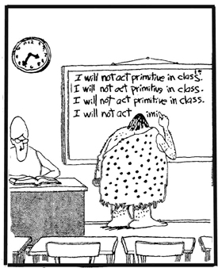
Examples of negative consequences:

- Time out (time away from positive things for a designated time period).
- Response Cost/Loss of Privileges (taking away a specific activity, object , or privilege for a designated time period for problem behaviors).
- Loss of Points (taking away points on a behavioral chart for problem behaviors).
- Ignoring Behavior (removing the attention gained from misbehaviors).

Negative Consequences are NOT:

- Threats – that are not carried out
- Yelling – which often teaches children not to pay attention unless yelling, or inadvertently gives attention to negative behavior.
- Overreaction – which may make problems worse by magnifying their importance
- Put-downs – which include insults, name-calling, accusations, and unfavorable comparisons to other children.

Tips on Effectively Using Negative Consequences:

Implement meaningful consequences -- Make sure that the consequence fits the circumstances.
- Follow-through with consequences – This may be difficult at first, since problem behaviors often increase before they get better. Remember that giving in even once will increase a problem behavior that you are trying to decrease.
- Don’t over-use the same consequences – The power of a consequence may wear off when the child gets used to it.
- State your child’s choices and the consequences – This helps the child learn to make decisions and take responsibility for actions.
- Try using natural and logical consequences – A natural consequence is one that results from going against the laws of nature (e.g. A child who refuses to eat gets hungry). A logical consequence is related to the problem behavior and helps the child learn the rules of social cooperation (e.g. A child might have to fix or replace something he/she has broken).

(Miller, 2002)

Response 2

Use Planned Ignoring for Attention-Seeking Misbehaviors

Planned ignoring is a strategy designed to change student behavior. It is an effective technique for eliminating problem behaviors when it is paired with positive interactions (4:1). Planned ignoring will not be effective if the majority of the teacher-student interactions are negative.

With planned ignoring, you reduce/eliminate the attention a student receives for engaging in a misbehavior, while concurrently giving the student frequent attention when s/he is not engaged in misbehavior.

The goal is for the student to learn that using misbehavior to get attention is ineffective, but that behaving responsibly results in frequent, positive attention.

Behaviors to Ignore:
Petty low-level misbehaviors directed to get the teacher’s attention:
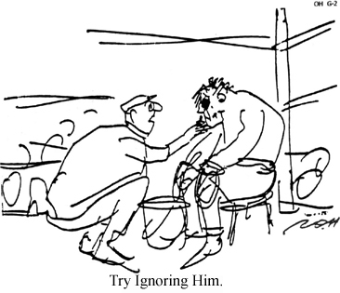
- Calling out
- Excessive helplessness
- Tattling
- Minor disruptions

Behaviors Not to Ignore:
- Misbehaviors supported by peers
- Misbehaviors that have a history of escalating
- Misbehaviors that are dangerous, threatening, or unsafe
- Automatically reinforcing behaviors (e.g., Self-stimulating behaviors)
- Behaviors that cause a “problem” in a public place

Steps to Planned Ignoring

Ahead of time:
Identify the behaviors that you WILL and WILL NOT ignore
- Determine whether the behavior is acceptable or whether the problem is with the frequency or duration of the behavior.
- Has the desired behavior been taught and practiced?
- Is the misbehavior one that has a history of accessing more staff attention than the desired behavior?
- The more defined these behaviors are, the greater the likelihood that you will be consistent. You won’t be as likely influenced by “how you feel at the time.”
- Did you know that your “good days” when you are feeling relaxed and refreshed are the days that you are more likely to be inconsistent?
Identify the behaviors you will REINFORCE

When Misbehaviors Occur:
- Continue doing what you are doing…TEACH!
- Provide positive feedback to the students doing the RIGHT THING. This helps you and your students focus on the desirable behavior.
- Do NOT state that you are ignoring – “I am ignoring you now,” shrug, sigh.
- Be consistent. Intermittent ignoring is worse than not ignoring
- When the misbehavior stops, give the student attention.
- Provide frequent attention with the student when s/he is not misbehaving (4:1) … PRAISE SPECIFICALLY. PRAISE OFTEN.

(TIEE, Date unknown)
Response 3

Subtleties of Ignoring:
- Begin to ignore when the student first begins to misbehave.
- The data shows that when you first initiate Planned Ignoring, the behavior often gets worse before it extinguishes.
- Avoid the following…
- Talking to add-ons
- Repeating directions
- Sympathetic or encouraging comments (e.g., I know this is hard.)
- Explaining or defending your behavior

Steps When Planned Ignoring is Not and Option:
- Give as little attention as possible to the misbehavior. Address the misbehavior in a brief, calm manner…Redirect, give and incompatible direction, provide an appropriate consequence
- Implement the student’s Behavior Plan

Teaching Students to Ignore Misbehavior:

Concentration Game

Challenge students to be able to work for a long period of time while you are trying to interrupt them. When they are doing well after a few trials, tell them that there may be occasions when someone doesn’t make a good choice and tries to interrupt their work.

Stopwatch

Use a stopwatch to keep track of the time and look official.

Chart to record minutes.

Progress monitoring has been shown to be an effective motivational tool. A visual picture of progress can be a reward in itself. Students can earn a class reward when they have reached a pre-determined goal.

Teach with examples and nonexamples.

Show students the right way to play the game and show them what is not o.k.

Practice for fun.

Play the game when all kids are doing well. Don’t give the message that you only do this when someone is misbehaving.

Rationale for the Concentration Game
- On-task behavior is the factor most associated with student achievement.
- Pre-teaching students to ignore distractions will:
- Prevent reinforcement of attention seeking behavior.
- Increase student on-task behavior.
- Prevent chaos during emergency situations.
- Prevent escalation of dangerous behavior.
- Help teachers maintain sanity.

(Sprague et. al., 2001)

Response 4

Diffusing Anger and Aggression

Safe Strategies for Secondary School Educators, Geoff Colvin (DVD), 1999

Managing Off-Task Behavior

Acknowledge students who are on task
- Redirect whole group
- Take student aside
- Redirect student
- Stay with direction
- Acknowledge cooperation
- Continue to acknowledge other on-task students
- If student does not cooperate, move to pre-planned consequence

Responding to Provocative Behavior

When a student is defiant, to avoid a power struggle:
- Speak privately to the student
- Identify the problem
- Ask the student to take care of the problem
- Present options
- Ask the student to select an option
- Acknowledge cooperation

Responding to Disrespectful Behavior

- Acknowledge on-task students
- Calmly indicate follow-up to the disrespectful student
- Continue with instruction

If student cooperates:
- Acknowledge cooperation
- Point out how behavior was disruptive
- Inform them that the next time behavior occurs there will be a consequence

If student continues to disrupt class
- Give class a small task to do independently
- Approach student privately and give warning or consequence

Guidelines for approaching a disrespectful student:
- Move slowly and deliberately toward the problem situation
- Speak privately
- Speak calmly
- Speak respectfully
- Minimize body language
- Keep a reasonable distance
- Establish eye-level position if possible
- Be brief
- Focus on expected behavior
- Withdraw if problem escalates
- Acknowledge cooperation
Response 5

Reducing Agitation

1. Identify the signs of agitation – Verbally recognize agitation of student

2. Use effective strategies to help student settle and resume class:
- State the expected task
- Communicate concern
- Allow space
- Attend to other students
- Assist student to begin work

Common strategies for reducing agitation:
- Teacher recognition and support
- Provide space
- Present options
- Teacher proximity
- Independent activities
- Movement activities
- Relaxation activities
- Involve the student in the plan

Establishing Limits

The teacher presents a choice and shifts the focus from himself to the choice:
- Present expected behavior and negative consequence as a choice or a decision
- Allow a few seconds for a decision
- Withdraw and attend to other students
- Acknowledge cooperation

Steps for establishing limits:
1. Use a non-confrontational delivery
- Present the expected behavior and negative consequence as a decision
- Allow a few seconds for the student to decide
- Withdraw from the student and attend to other students
2. Follow through
- If the student cooperates, briefly acknowledge the choice and move to other students.
- If the student does not cooperate, follow through with the consequence.

Responding to Crisis Behavior

When students present a serious threat, or behavior indicates drug or alcohol use, follow emergency procedures, and get help:

1. Pause and assess – Do not respond immediately. Look at the floor, look at the student. Keep still. Ask yourself, “Is this an emergency situation?” If your answer is “yes,” move to the next step.

2. Physically disengage and send for help – Say to the student very calmly, respectfully and firmly, “Just a second,” and at the same time step back in a calm and deliberate manner. Without looking at the student, move to the nearest classroom and follow your school’s emergency procedures.

The most important consideration is SAFETY FIRST. There is no shame or loss of respect with disengaging from dangerous situations. Never feel obligated or pressured to take care of such situations by yourself.

Response 6

Build Problem Solving Skills

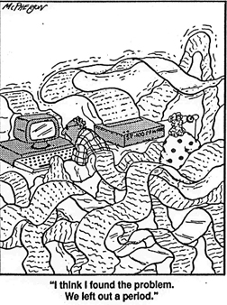

Use the STAR Model to Encourage Thinking Before Acting
 |  |  | STAR
Stop |  |  | - Take enough time to make a good choice.  - Use calming strategies if needed
Think | 😐 |  | - Identify the problem  - Decide how you feel about the problem  - Think of choices that would be safe, respectful and responsible. (use problem solving wheel)  - Consider what might happen if you make each choice.
Act |  |  | - Act out your best choice; or talk about it with someone who can help.
Review | ☺ |  | - Ask yourself, “Did my action help me reach my goal?” or “Was my choice safe, respectful and responsible?”  - Explain how to prevent the problem in the future
Calming Strategies |  |  |  |  | Problem Solving Wheel
  Deep breaths |  | 1, 2…10  Count to 10 |  |   Use a fidget | 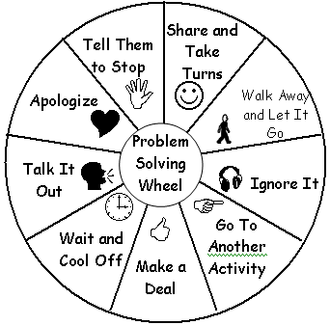
↓  Find a quiet place |  | 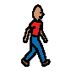  Walk |  |   Exercise
  Listen to music |  |   Write or draw |  |   Read
Problem Solving 1
Teach Sensory Strategies to Help Manage Stress

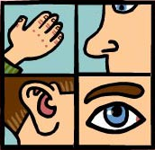

Many students with learning or behavioral difficulties have nervous system differences which make them overly sensitive to visual, auditory, and other sensory stimuli. This can result in a constant underlying state of stress which makes it difficult for the student to cope with even minor additional stesses and changes in routine.

Opportunities for movement, particularly deep pressure to the joints, and heavy muscle work, can help to calm and organize the nervous system. The physical effects of this type of activity can last up to two hours. Providing this helpful input on a regular basis throughout the day is called a “sensory diet.”

These are examples of activities which can be incorporated into the daily school routine:

- Push desks or stack of chairs
- Carry stacks or boxes of books
- Pass out books to classmates
- Push open and hold the door when class goes in or out
- Push or pull heavy cart or wagon
- Carry a full backpack or fanny pack when going to music, lunch, etc.
- Stomp or jump when changing activities within the classroom
- Rock in a rocking chair
- Relax in an upholstered or beanbag chair under a heavy blanket or pillow
- Erase chalkboard
- Wipe tables
- Pull on strings to adjust window blinds
- Chew on heavy duty straws at lunch time
- Chew on licorice, beef jerky, hard pretzels, fruit leather, or chewing gum
- Find a quiet, non stimulating area to take a break when overwhelmed
- Use fidgets to keep hands occupied
- Exercise

Guidelines for using strategies at school:

- Create a “menu” of appropriate sensory strategies for student to choose from
- Be sure to let students know what activities are appropriate at what time
- Start by prompting student to use strategies when they begin to look agitated
- Teach them to recognize the signs of their own agitation, and choose an appropriate strategy

Problem Solving 2

Teach Students to Think Differently

The creative-cognitive, thinking-then-doing process fosters problem solving. Creative, dynamic thinking and problem solving is essential for learning and psychological development. All of our heroes of math, the arts, science and literature were creative thinkers, doers and problem solvers. Thinking differently is the key!

The Thinking, Feeling and Actions Connection

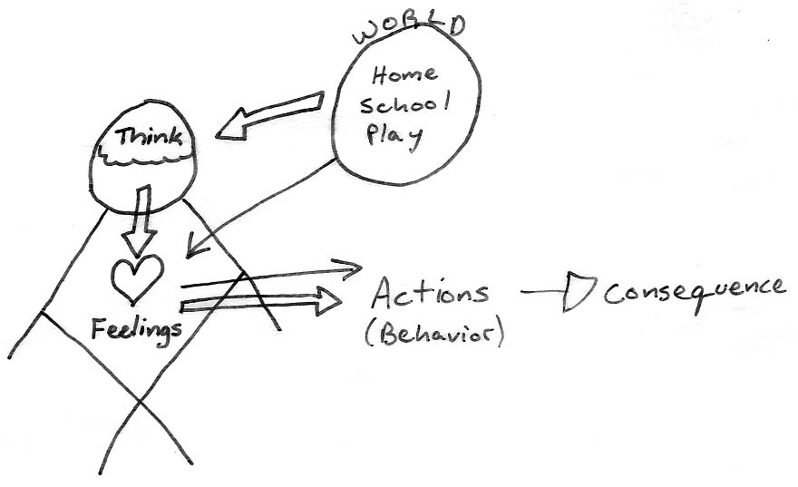

Teach students to recognize how their thoughts and feelings affect their actions.

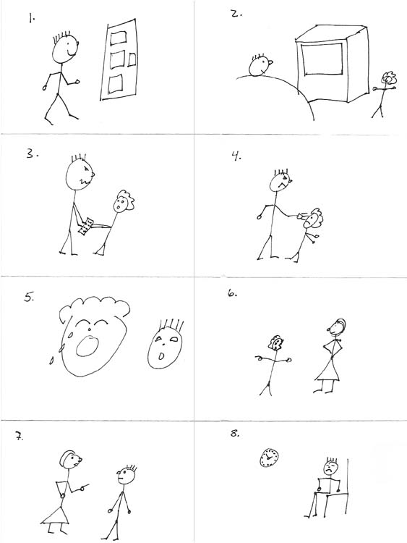 | Three Fold Sequencing  - Fold paper in half lengthwise, then in fourths the other way  - Number the boxes  - Have student draw a comic strip of a choice they made and the consequence.  - Cut out the part where they made a poor choice, and paste on a new page.  - Have student draw a different choice they could have made with a positive consequence.

White, 2005
Problem Solving 3
Train Your Brain
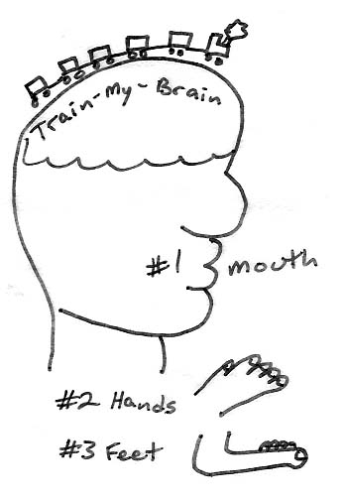 | Teach students that they are “the boss” of their brains, and can learn to train it to think differently.  There are 3 parts of the body that can get you in trouble:  - Mouth  - Hands  - Feet

First Thought – Second Thought
- We all have immediate thoughts about a situation, and delayed thoughts.  - Our first thoughts can often lead us to bad choices if we act before thinking things through. Our second thoughts usually lead us to the consequences of our actions.  - Impulsive students usually act before their second thought comes, and then feel bad about the consequences.  - Teach students to decrease the time before the second thought occurs, and increase the time before acting. | 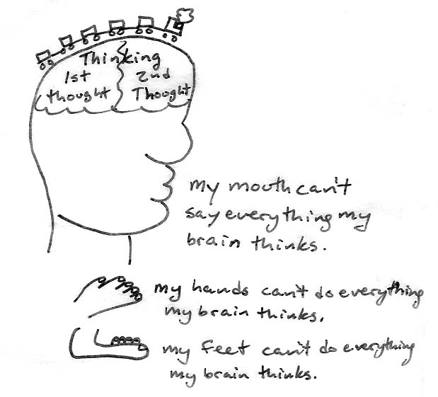

White 2005

Problem Solving 4

Understand the Function of Behavior

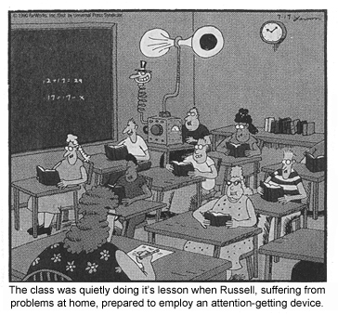

Understanding Functional Behavior Assessment
The ABCs of Behavior:

Antecedent – What usually occurs before the behavior?

Behavior – What are the problem behaviors?

Consequence – What events typically follow the behavior?

Setting Events are internal or external events that occur earlier and make a student more likely to respond to antecedent with problem behavior.

Functional Behavior Assessment
Setting Events | Antecedents/Predictors | Problem Behaviors | Maintaining Consequences
Internal events:  - Medication  - Poor physical health  - Hungry  - Tired  - Low academic skills  - Other: _________________  External events:  - Earlier Conflict  - Extended period without movement  - Extended period without attention  - Seated next to non-preferred student  - Drug use  - Other: _________________ | - Demand/Request  - Difficult Task  - Transitions  - Interruption  - Alone (no attention)  - Independent work  - Attention from peer  - Lack of supervision  - Transition  - Little structure  - Confrontation  - Other ______________ | Safety:  - Assault  - Self  - Peers  - Adults  - Threats  - Other ________________  Respect:  - Abusive Language  - Defiance  - Harassment  - Disrespectful language  - Classroom disruption  - Destruction of property  - Theft  - Other ________________  Responsibility:  - Off Task  - Lack of work completion  - Out of assigned area  - Other________________ | Gain/Obtain:  - adult attention  - peer attention  - preferred activity  - status among peers  - revenge  - power/control  - sensory stimulation  - tangible Object  - Other_________________  Escape/Avoid:  - work/assignment/ request  - escape from school  - specific person  - sensory stimulation  - Other_________________

Individualizing 1
Competing Behavior Model
(O’Neill et. al.)

The competing behavior model is based on the idea that in order to eliminate a problem behavior, we must first identify the function of the behavior, and then find positive ways that a student can obtain the same results.

Sample Competing Behavior Model
Setting  Events |  | Predictors  (Antecedents) |  | Preferred/Desired  Behavior |  | Consequence
No Peer Contact in Past 30 Minutes | + | Independent Work Assignment |  | Do Assignment | ➔ | More Work
No Peer Contact in Past 30 Minutes | + | Independent Work Assignment |  | Problem Behaviors |  | Maintaining  Consequence
No Peer Contact in Past 30 Minutes | + | Independent Work Assignment | ➔ | - Talking out  - Out of Seat | ➔ | Obtain Peer Attention
No Peer Contact in Past 30 Minutes | + | Independent Work Assignment |  | Replacement Behavior |  | Obtain Peer Attention
No Peer Contact in Past 30 Minutes | + | Independent Work Assignment |  | Request peer attention at appropriate time |  | Obtain Peer Attention

In this sample, the problem behaviors of talking out and getting out of seat serves the function of obtaining peer attention. If a student does what is expected of them, by doing the assignment, they get more work without peer attention. In order to get peer attention appropriately, they need an acceptable way to get it without disrupting the class.
Sample Behavior Support Plan
Setting  Events |  |  | Predictors  (Antecedents) |  |  | Preferred/Desired  Behavior |  |  | Consequence
Number of days without access to desired item | + |  | Peer with desired item |  |  | Wait turn to get item | ➔ |  | Delayed access to item
Number of days without access to desired item |  |  | Peer with desired item |  |  | Problem Behaviors |  |  | Maintaining  Consequence
Number of days without access to desired item |  |  | Peer with desired item | ➔ |  | - Pinching  - Scratching | ➔ |  | Obtain item
Number of days without access to desired item |  |  | Peer with desired item |  |  | Replacement Behavior |  |  | Obtain item
Number of days without access to desired item |  |  | Peer with desired item |  |  | Ask peer to share item |  |  | Obtain item
What are ways to change the context to make the problem behavior unnecessary? |  | What are ways to prevent the problem behavior? |  |  | What can be done to increase expected behaviors or to teach a replacement behavior? |  |  | What should happen when a problem behavior occurs?
Provide frequent or ongoing access to desired items |  | Remind student to ask peers to share item or ask teacher for item |  |  | Teach student to ask peer to share item  Teach student to wait turn to access item  Teach student to ask teacher for item |  |  | If student pinches or scratches, attempt to make sure he doesn’t get access to item
 |  |  |  |  |  |  |  | What should happen when desired or replacement behavior occurs?
Arrange with peers to provide items if he requests appropriately

If student asks teacher for item appropriately, provide item
Setting Event Strategies |  | Predictor Strategies |  |  | Teaching Strategies |  |  | Consequence Strategies
Individualizing 2
Behavior Support Plan
(O’Neill et. al.)
Setting  Events |  | Predictors  (Antecedents) |  | Preferred/Desired  Behavior |  | Consequence
- Hungry  - Tired  - Earlier Conflict  - Extended period without movement  - Extended period without attention  - Seated next to non-preferred student  - Other ____________ | + | - Demand/Request  - Difficult Task  - Transitions  - Interruption  - Alone (no attention)  - Independent work  - Attention from peer  - Lack of supervision  - Transition  - Little structure  - Confrontation  - Other ______________ |  |  | ➔
 | + |  |  | Problem Behaviors |  | Maintaining  Consequence
 | + |  | ➔ |  | ➔ | Gain/Obtain:  - teacher attention  - peer attention  - preferred activity  - status among peers  - revenge  - power/control  - access to drugs/alcohol  - sensory stimulation  - Tangible Object  - Other: ____________  Escape/Avoid:  - avoid work/assignment/ request  - escape from school  - specific person  - sensory stimulation  - Other: ____________
 | + |  |  | Replacement Behavior | 

List Strategies that Make the Problem Behavior Irrelevant, Ineffective, & Inefficient

What are ways to change the context to make the problem behavior unnecessary? | What are ways to prevent the problem behavior? | What can be done to increase expected behaviors or to teach a replacement behavior? | What should happen when a problem behavior occurs?
- Clarify rules and expected behavior for whole class  - Change seating arrangements  - Change schedule  - If hungry, give food  - Counseling  - Other: | - Reminders about behavior when problem behavior is likely  - Provide extra assistance  - Modify assignments to match student skills:  - Shorter assignments  - More time  - Mix easy and hard tasks  - Check in frequently  - Give choices among tasks  - Work in small groups to provide attention  - Work independently to avoid distractions  - Use timer for independent work to earn ___________:  - Signature for ___ min.  - Reward for ___ signatures  - Other: | - Teach student to ask for help appropriately  - Teach student to wait for help when needed  - Give prompts for expected behavior  - Develop ability to complete independent work  - Practice expected behavior in class:  - Other: | - Ignore behavior unless unsafe or disruptive  - Specific Response Sequence:  - Reminder  - Take 2  - Think Time  - Time out in class  - Time out in TO room  - Immediate time out in TO room if unsafe  - Other:
 |  |  | What should happen when desired or replacement behavior occurs?
- Higher Level
- Praise from teacher
- Provide attention when requested appropriately
- Reward for signatures from timer
- Other:
Setting Event Strategies | Predictor Strategies | Teaching Strategies | Consequence Strategies
Individualizing 3
 |  | Behavioral Analysis
 |  |  |  | 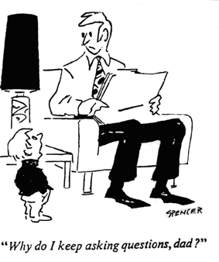 |  |  | 
Child experiences intense stress that interferes with acquisition or performance of social skill | Child does not know the social skill or when to use the skill | Child knows the social skills but is unable to use it consistently and independently |  |  |  |  | Child knows the social skills but refuses to use it.  Determine why.
⬇ | ⬇ | ⬇ |  |  |  |  |  ⬇ |  | ⬇ |  | ⬇
When necessary, change the environment to a place where the child can calm down  - Teach skills to reduce & manage emotional arousal, and/or increase self-control  - Reward skill uses  - Pair skills with other social skills | Teach the skill  - Practice the skill  - Cue the skill in real-life situations  - Reward skill use  - Accommodate when necessary | Provide prompts, cues and reminders – make them fun and visual  - Reward frequently and provide consequences when necessary  - Provide novelty, variety & structure  - Celebrate successes  - Accommodate when necessary |  |  |  | Attention | Control |  | Revenge |  | Inadequacy
 |  |  |  |  |  | ⬇ | ⬇ |  | ⬇ |  | ⬇
 |  |  |  |  |  | Ignore behavior that is not a danger to self, others or property  Pay Attention to and reward good behavior  - Provide consequences when necessary | - Avoid power struggles – set firm limits and follow-through with consequences  - Provide limited choices & allow child to help with decision-making  - Foster leadership opportunities |  | Avoid being hurt and striking back in anger  - Build trust  - Help the child feel loved |  | Cease all criticism  - Recognize effort – even small steps  - Highlight strengths and provide mastery experience

⬇

Consider possible biological, cultural and developmental factors
Interfering  Behaviors | Skill-Based | Performance-  Based |  |  |  | Motivation - Based
(Gillingham & Fong, 2001)

Individualizing 4

Using behavior contracts

Steps in implementing a behavior contract  - Decide on one or two behavior goals to focus on that are:  - Broad  - Clearly worded  - Stated positively  - Realistic  - Clearly define expectations for each rating  - Decide on terms for rewards  - Decide on reward(s) with student | Resolving common problems  - Have the student participate in planning the contract to help them buy into it  - Clarify the terms with the student  - Make sure that the rewards are reinforcing to the student, and change them often  - Make sure that points are rewarded frequently enough to keep student engaged

Sample behavior contract

Student Name: ______________________________ Date: _________________________
 | Time Periods
Goal |  |  |  |  |  |  |  |  |  | Daily  Average

Stays in assigned area

Completed work
 |  |  | Comments:

1 – Serious problem

2 – Does not meet expectations

3 – Approaching expectations

4 – Meets expectations

5 – Exceeds expectations
Parent Signature: _____________________________________

Sample behavioral expectations
Goal | Level 1 | Level 2 | Level 3 | Level 4 | Level 5
Stays in Assigned Area: | Refusing to stay at your desk  Leaving any area without permission (classroom/lunchroom/ PE/music)  Refusing to go to Time Out  Refusing to go to assigned activity or area | Many reminders to stay in seat  At desk but not sitting in chair  Slow to line up after activities  Getting into stuff you are not suppose to (Teacher’s desk, cabinets, cubbies, etc.) | 2 or 3 reminders to stay at desk  Leaving line when going to other areas  Cutting off corners, not following in line  Running ahead of teacher when in line | 1 reminder to stay in seat  Walking in line correctly | Do not get out of desk without asking  Stay in line where you start  Do not leave any area (classroom, music, PE, etc.) without permission
Completes Work: | Does no work at all or almost no work  Refusing to participate in an activity | Get at least a small part of the assignment done | Tries to finish work  May need several corrections | Finish or almost finish work in given time  Needs few corrections | Finish you assignment in the time given  Do your work correctly with few errors

Individualizing 5

Using Social Stories to Increase Positive Behavior

Steps in developing a social story:
- Identify target behavior
- Define behavior
- Answer wh-questions
- Identify reinforcer if necessary
- Identify replacement behaviors if necessary
Questions to consider:

Is there an introduction, body & conclusion?

Does the story answer the relevant “wh” questions?

Is it written from a first person perspective?

Does the story have a positive tone? Is negative information stated carefully?

Is the story literally accurate?

Is alternative vocabulary used in place of terms that may cause the child to become upset or nervous?

Is the text written with consideration of reading ability and attention span of the child?

If illustrations are used are they simple & direct?

Are necessary reinforcers & replacement behaviors included?

Overall, does the story have a patient and reassuring quality?

Sample Social Story
When my teacher tells me to start  I can pick up my pencil and write  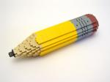 |  | When I don’t understand  I can ask questions   |  | When I need help  I can ask someone  
When I get frustrated  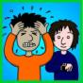 | I can take a deep breath or   |  | I can walk away to another part of the room  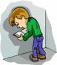 |  | I use this book to help me when I get stuck.  

Individualizing 6

Be Patient

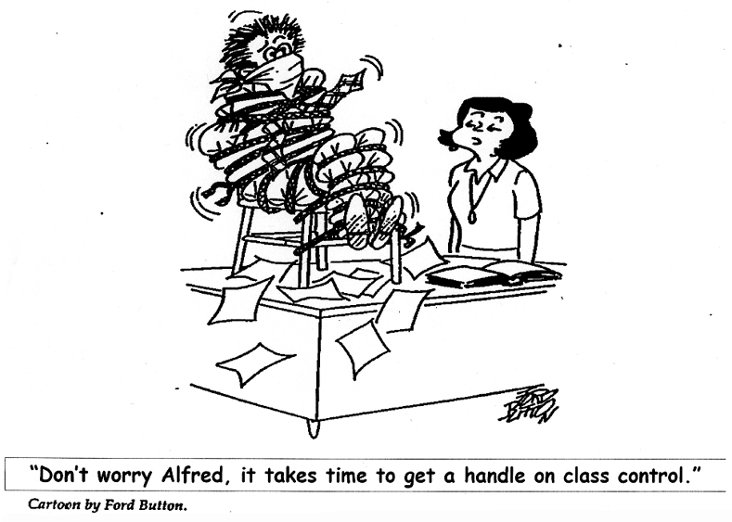

Remember…

Effective behavior practices will often seem to make things worse before they get better.

Give new plans at least a two-week trial before deeming them ineffective.

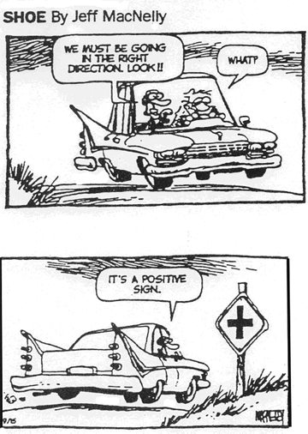
Patience 1
Effective Behavior Management Rating

Establishing Expectations

Behavioral expectations are clear
□ | □ |  | □ | □ |  | □ | □ | □
Behavioral expectations are not clear |  | Behavioral expectations are taught, but not practiced |  |  | Behavioral expectations are taught and practiced once |  | Behavioral expectations are taught, practiced and refreshed throughout the year

Reinforcing Expected Behavior

Exhibits positive, enthusiastic persona
□ | □ |  | □ | □ |  | □ | □ |  | □
Seldom displays positive affect |  | Selectively displays positive affect |  |  | Usually displays positive affect |  |  | Displays positive affect consistently under all work situations

Delivers praise effectively
□ | □ |  | □ | □ |  | □ | □ |  | □
Consistently uses more negative feedback than positive feedback |  | Uses equal positive and negative feedback |  |  | Uses more positive feedback than negative feedback |  |  | Consistently achieves 4 to 1 positive to negative feedback even with most difficult students

Modulates affect effectively
□ | □ |  | □ | □ |  | □ | □ |  | □
Uses annoyed or persuasive affect to engage off task students |  | Affect remains the same regardless of student behavior |  |  | Usually uses animated affect with positive behavior, and flat affect with off task behavior |  |  | Consistently uses animated affect with positive behavior, and flat affect with off task behavior

Giving Directions

Directions are given clearly
□ | □ |  | □ | □ |  | □ | □ |  | □
Directions given with arguments or persuasive comments |  | Directions wordy or over explained |  |  | Directions are usually clear and brief |  |  | Directions are consistently clear and brief

Directions are given effectively
□ | □ |  | □ | □ |  | □ | □ |  | □
Directions are constantly repeated |  | Directions are frequently repeated |  |  | Directions are occasionally repeated |  |  | Directions are consistently given once

Appropriate expression is used when giving directions
□ | □ |  | □ | □ |  | □ | □ |  | □
Directions are given with a raised, irritated or coaxing voice |  | Directions are given with a hint of emotion in voice |  |  | Directions are usually given with a flat, even tone of voice |  |  | Directions are consistently given with a flat, even tone of voice

Appendix i
Responding Appropriately

Maintains consistency with consequences
□ | □ |  | □ | □ |  | □ | □ |  | □
Consequences are constantly changing according to mood |  | Consequences are occasionally inconsistent |  |  | Consequences are usually consistent |  |  | Consequences are preplanned and consistent

Uses ignoring strategically
□ | □ |  | □ | □ |  | □ | □ |  | □
Ignores too much or not enough |  | Follows rules to ignore |  |  | Uses ignoring strategically |  |  | Reliably uses ignoring strategically even with the most difficult students

Encouraging Problem Solving

Problem solving is used effectively
□ | □ |  | □ | □ |  | □ | □ |  | □
Consistently steps in to solve problems for students |  | Frequently steps in to solve problems for students |  |  | Steps in to solve problems for students only when needed |  |  | Helps facilitate students in using problem solving independently

Understanding Behavior

Helps students find positive behaviors to meet their wants
□ | □ |  | □ | □ |  | □ | □ |  | □
Student’s wants met only with negative behavior |  | Students’ wants met more with negative behavior than positive |  |  | Students’ wants usually met with positive behavior |  |  | Students’ wants met consistently with positive behavior

Monitor Behavior

Monitors students
□ | □ |  | □ | □ |  | □ | □ |  | □
For safety issues only |  | Prompts, payoffs, corrects behavior of assigned students |  |  | Looks around, moves around, interacts |  |  | Prompts, payoffs, corrects behavior of any student present

Maintaining Patience With Programs

Gives new behavior approaches a sufficient amount of time to establish effectiveness
□ | □ |  | □ | □ |  | □ | □ |  | □
Constantly changes behavior approaches |  | Gives new behavior approaches less than 2 weeks to determine effectiveness |  |  | Gives new behavior approaches 2-4 weeks to determine effectiveness |  |  | Gives new behavior approaches 2-4 weeks of consistent practice to determine effectiveness

Appendix i
Classroom observation form

Instructor: | Observer: |  | Date:
Subject/Lesson: | Begin Time: | End Time: |  | Time Total:

Positive Consequences |  | Negative Consequences
Praise | Other | Rules | Penalties
Academic Performance
Social Performance
Examples:
Percent Positive Consequences:
100 x Positives/(Pos. + Neg.)

Is lesson delivered fluently?  Are materials organized and ready to go?  Is transition time quick and smooth?  Are procedures evident?  Is praise used to shape behavior?  Does instructor direct/focus student’s attention?  Are directions given clearly?  Is instructors voice used effectively?  Are errors corrected appropriately?  Are students able to problem solve?  Are students monitored? | Hi  Hi  Hi  Hi  Hi  Hi  Hi  Hi  Hi  Hi  Hi | M  M  M  M  M  M  M  M  M  M  M | Lo  Lo  Lo  Lo  Lo  Lo  Lo  Lo  Lo  Lo  Lo

Appendix ii

Sample Procedures

Following Directions  When given a direction:  - Look at the person.  - Say “OK.”  - Do what he/she asked. | STAR  When you have a problem:  - Stop and calm down  - Think about the problem & possible choices  - Act out best choice  - Review your choice
Take-2  When you feel angry or upset:  - Say “I want to Take-2.”  - Walk to the Take-2 area.  - Take deep breaths. Say “I am calm.”  - Go back to class when you are calm. | Transitioning  When given a direction to transition:  - Check your schedule.  - Get your stuff.  - Walk to your next group.  - Wait at the door.
Good Ignoring  When someone is doing something distracting:  - Decide whether you can ignore  - If you can ignore, keep doing what you are doing.  - If you can’t ignore, problem solve. | Getting Teacher’s Attention  When you want to get a teacher’s attention:  - When sitting, raise your hand  - At other times, say “excuse me.”  - Wait for the teacher
Think Time  When asked to take a “Think Time”:  - Sit with your hands folded.  - Wait for the next direction. | Starting Class  When you arrive in class:  - Sit in your seat.  - Organize your materials.  - Wait for the next direction.
Getting On the Bus  When you are dismissed from class:  - Walk directly to your bus area.  - Line up at your bus.  - Get on the bus calmly. | Fire Drill  When the fire alarm sounds:  - Line up with your class.  - Follow class to designated area.  - Wait for the next direction
Earthquake  When the teacher says “Earthquake”  - Stop  - Drop  - Cover  - Wait | Accepting Feedback  When the teacher tells or asks you something:  - Say “OK” or do it.  - If it is hard feedback, problem solve.

TIEE 2001

Appendix iii
References and Resources:

Miller, Danielle R. Ph.D. Negative Consequences: Helping Children Develop Positive Behavior. Learning Development Services, March 2002.

Colvin, Geoff, Ph.D. Diffusing Anger & Aggression. Iris Media, 1999.

Glasser, Howard. Transforming the Difficult Child: The Nurtured Heart Approach.

http://www.frsd.k12.nj.us/autistic/Parent%20Training/social%20stories.htm

http://www.usevisualstrategies.com/information.html

O’Neill, Robert, Horner, Robert, Albin, Richard, Sprague, Jeffrey, Storey, Keith, Newton, Stephen. Functional Assessment and Program Development for Problem Behavior

Sprague, Jefferey, Ph.D., Bernstein, Lori, M.S., Munkres, Arden, M.F.A., Golly, Annemieke, Ph.D., March, Robert, Ph.D. Building Effective Schools Together: B.E.S.T Practices Participant Manual. Institute on Violence and Destructive Behavior, 1999.

Taylor, Mary. Modulation & Differential Reinforcement as Effective Teacher Practices for Managing Behaviors. The Institute for Effective Education, 2001.

The Institute for Effective Education (TIEE). Attention-Seeking Misbehaviors and Planned Ignoring. Date unknown.

The Institute for Effective Education (TIEE). Procedure Training. 2001.

The Institute for Effective Education (TIEE). Safe Response Training Student Manual. October, 2000.

White, Paul, LCSW. Play Therapy and Beyond: Treatment Techniques and Strategies with Children and Pre-Adolescents. Cross Country Education Inc. 2005.

Appendix iv

