You can be a STAR Lesson Plan

Day 1 – Recognizing Feelings (Slides 1-4)

Slide(s) | Activity
2 | Feelings are something I feel in my body (handout)
4 | Discuss how they feel when feeling stormy & different ways to feel stormy.

Day 2– Stop (Slides 5-11)

Slide(s) | Activity
11 | Cut out calming strategies and paste favorites to STOP sign (handouts)

Day 3– Think (Slides 12-15)

Slide(s) | Activity
14 | Cut out favorite problem strategies and paste to light bulb (handouts)

Day 4– Act & Review (Slides 16 & 17)

Slide(s) | Activity
16 & 17 | List examples and non-examples of the expected behaviors:  - A positive example:  Sarah was in a hurry to go to the bathroom. She wanted to run down the hall, but chose to walk so she wouldn’t run into anyone.  - A non-example:  Johnny has a big test tomorrow, and he really needs to study. His best friend comes over and asks him to play, so he runs out the door to play with his friend.  - A positive example:  Mary accidentally bumped in to Anne, and Anne thought that she did it on purpose. She thought about what would happen if she hit Mary, and decided to ask her why she bumped into her instead. Mary explained that it was an accident, and Anne forgave her.  Role Play Scenarios  E.g. At recess, a ball comes toward you from another game, and you want to kick it out of the way, what do you do? (Stop, Think – kicking it might hurt someone, what else can you do? Act out the safest choice, Review – decide if you made a good choice.

Feelings are something I feel in my body.
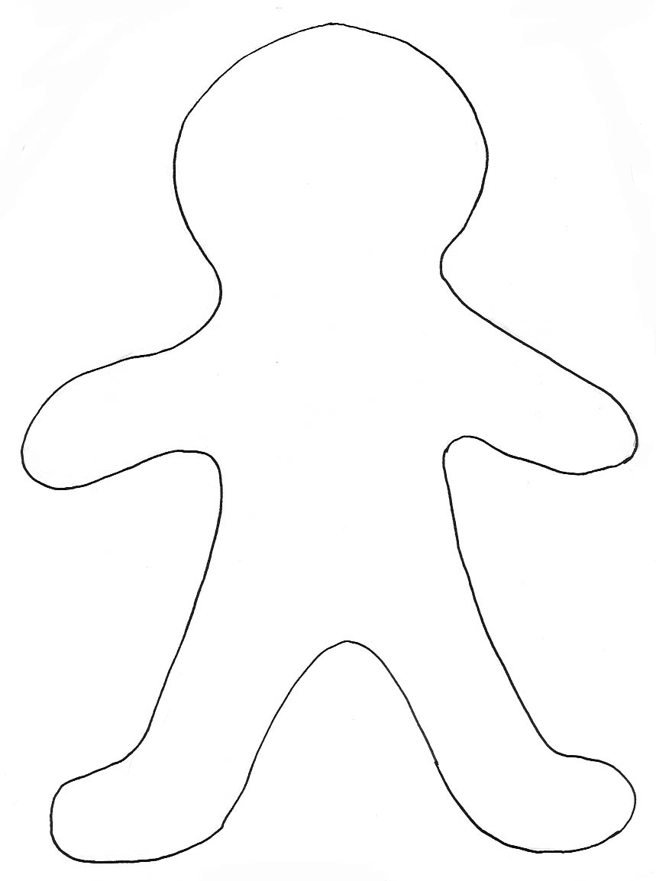
Color the places you feel your feelings with these colors:
Mad – red | Sad – blue | Glad – yellow | Scared- purple

Cut out your favorite calming strategies and glue on to the stop sign.
STOP

Take Deep Breaths  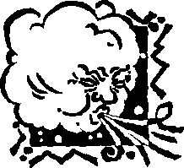 |  |  |  | Stretch  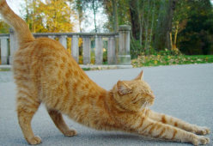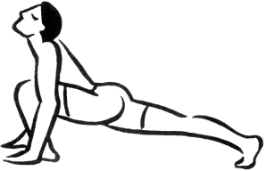
Use a fidget  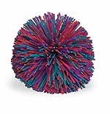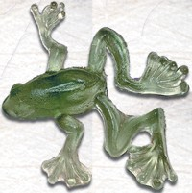 |  |  |  | Find a quiet place  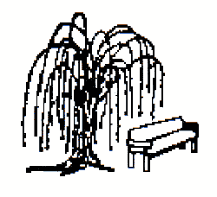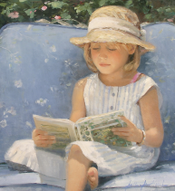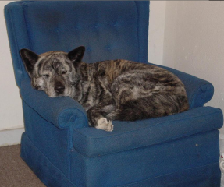
Walk  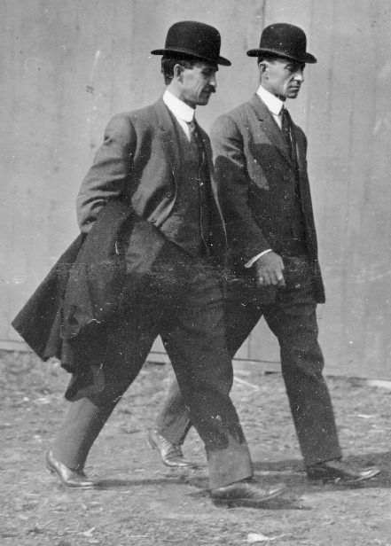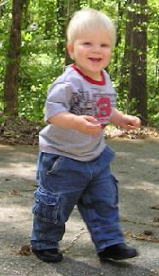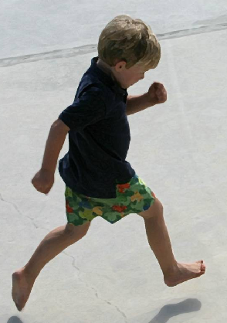 |  | Exercise  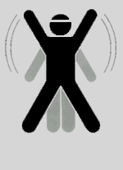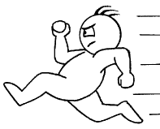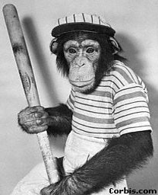
Count to 10  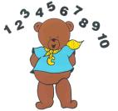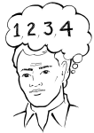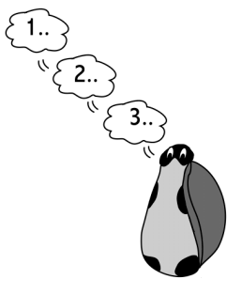 |  |  |  |  | Move & Shake  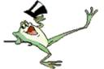
Listen to music  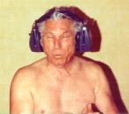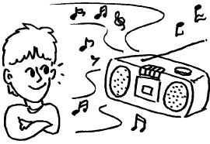 |  |  | Write or draw  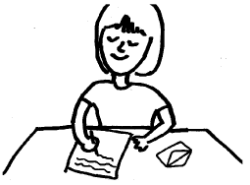
Read  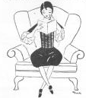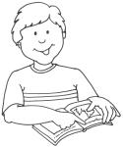 | Imagine  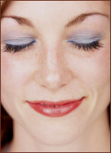 |  |  |  |  | Relax muscles  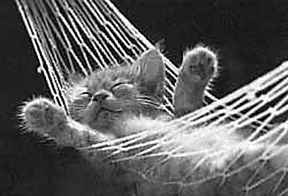


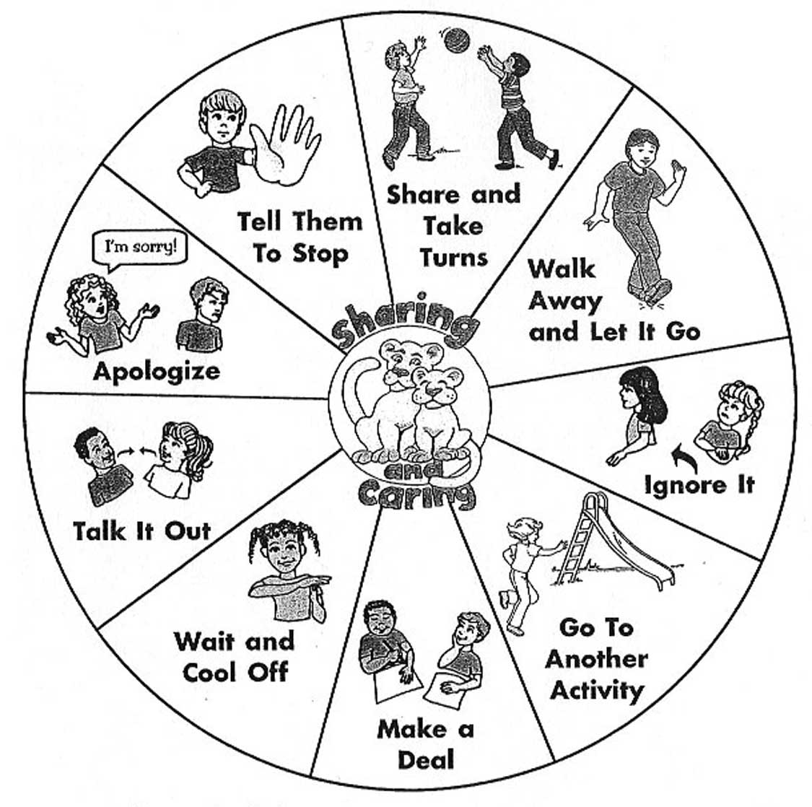

Cut out your favorite problem solving strategies and glue onto the light bulb.

